Homework #4, 繳交期限 2024/12/06

Generative and Neural Style Transfer

系所：工海所

姓名：劉樺

學號：R13525030

Basic

請於本作業提供之畫作(style image)資料集中選擇一張照片，並由本作業提供之真實照片(content image)資料集中選擇一張照片，以HW4_sample_code.ipynb (Python) 程式：將真實照片轉換為畫作風格

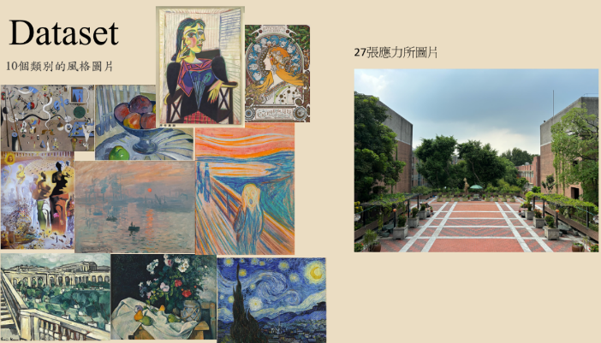

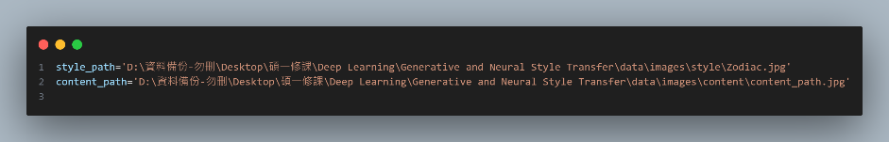

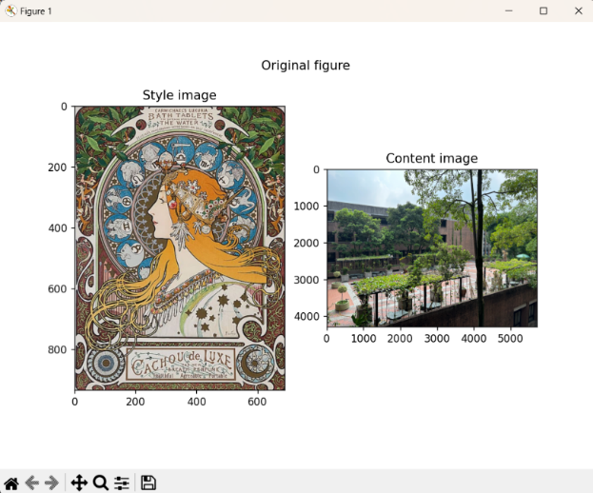

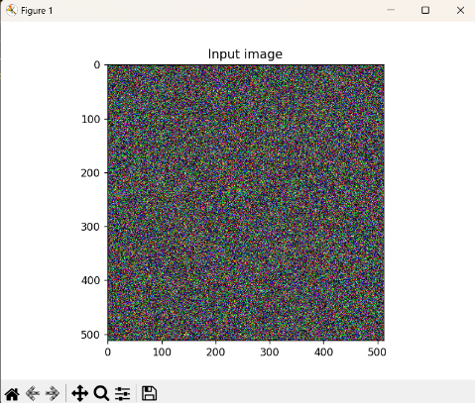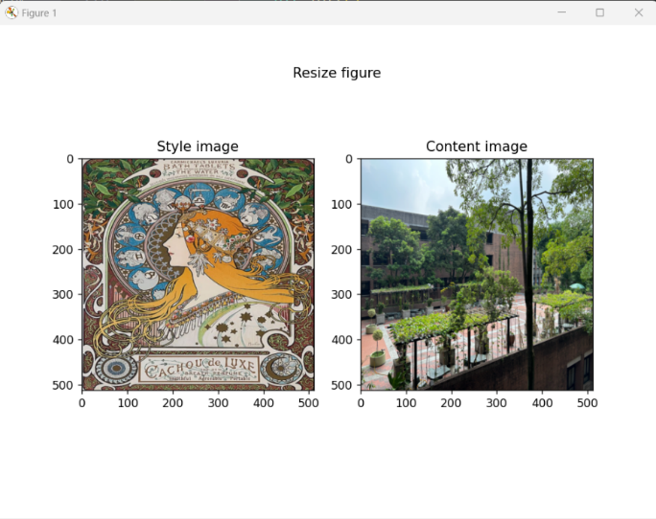

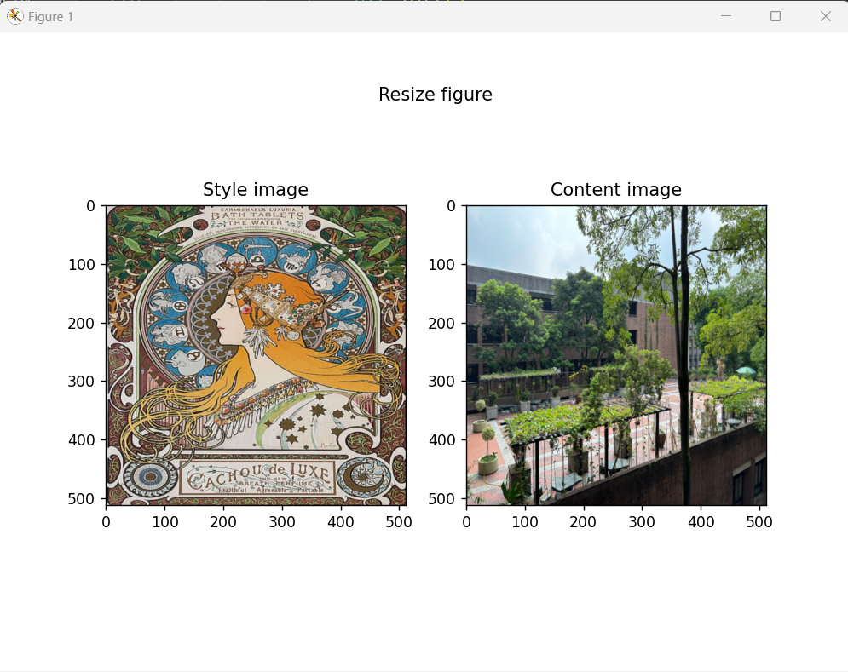

|  |  |  |  |  |
| --- | --- | --- | --- | --- |
|  |  |  |  |  |
|  |  |  |  |  |
|  |  |  |  |  |
|  |  |  |  |  |
|  |  |  |  |  |
|  |  |  |  |  |
|  |  |  |  |  |
|  |  |  |  |  |

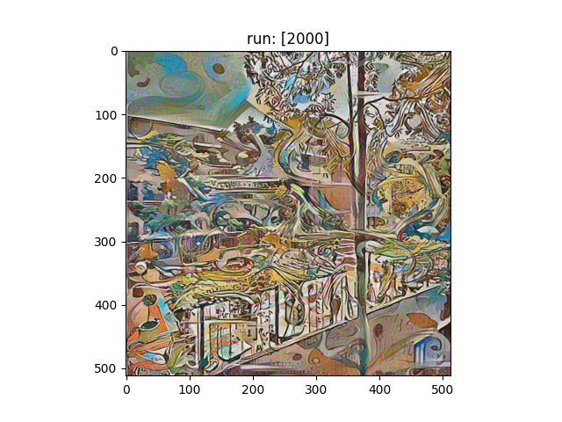

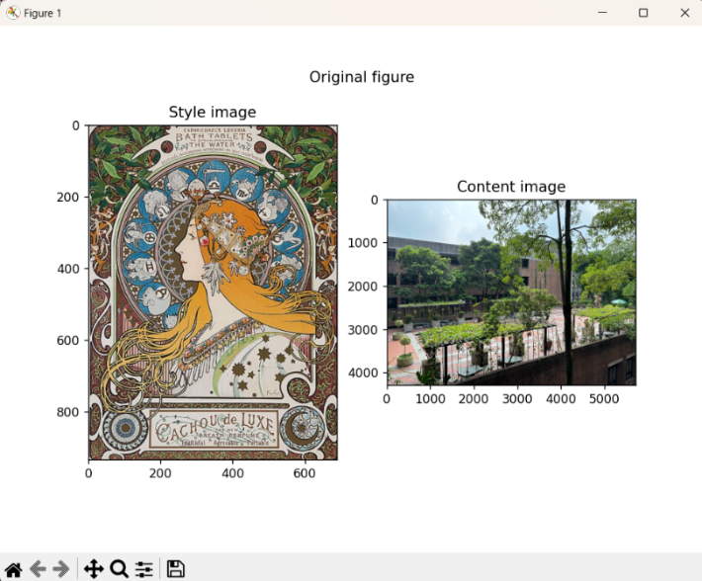

Homework #4, 繳交期限 2024/12/06

Generative and Neural Style Transfer

系所：工海所

姓名：劉樺

學號：R13525030

Intermediate:

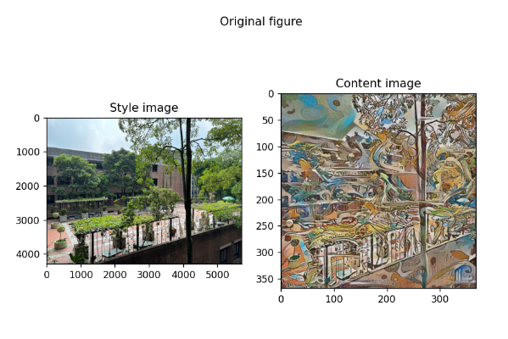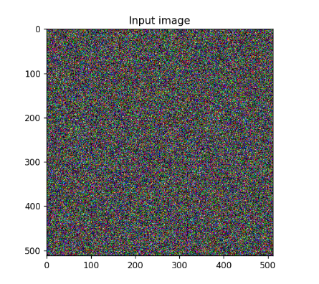將剛剛轉換完成之照片，透過反向操作重新轉換回真實照片的風格。(將Basic level轉換完成之照片另存新檔並當成content image，以原照片當成style image，透過修改路徑，將其風格轉換回來)

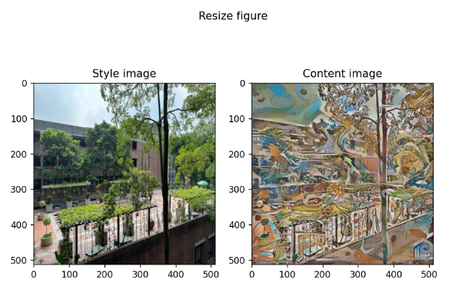

|  |  |  |  |  |
| --- | --- | --- | --- | --- |
|  |  |  |  |  |
|  |  |  |  |  |
|  |  |  |  |  |
|  |  |  |  |  |
|  |  |  |  |  |
|  |  |  |  |  |
|  |  |  |  |  |
|  |  |  |  |  |

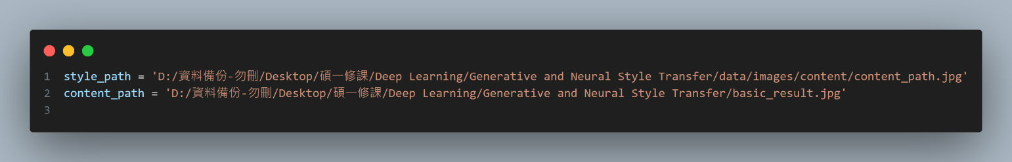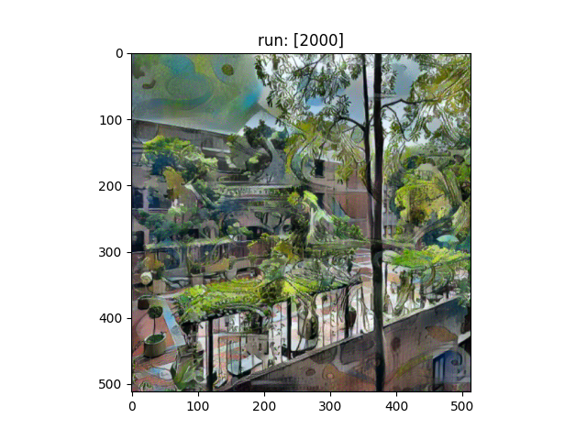

Homework #4, 繳交期限 2024/12/06

Generative and Neural Style Transfer

系所：工海所

姓名：劉樺

學號：R13525030

Advanced

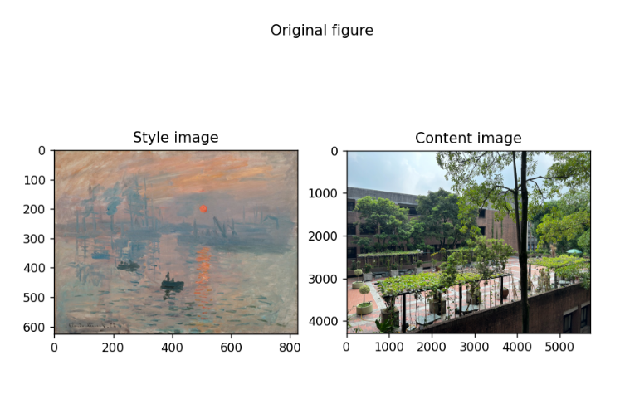改變捲積神經網路萃取之層或層數，以達成更好之轉換效果。

